Chapter 12, Problem 12.

Using Fig. 12.45, design a problem to help other students better understand wye-delta connected circuits.
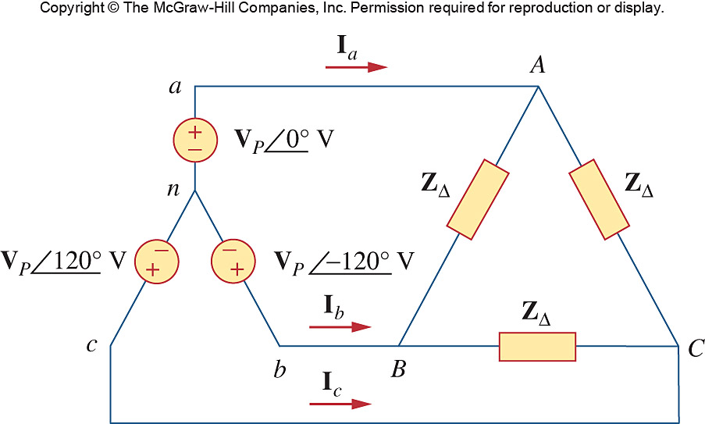

Figure 12.45
For Prob. 12.12.

